Press release Sulz am Neckar, Germany, March 2017

Secure locking with a flick of the wrist

KIPP introduces new locking elements

The HEINRICH KIPP WERK is expanding its range with some practical locking elements that can join two separate plates with a defined force. A full and secure fastening can be carried out with just a flick of the wrist. With new quarter-turn clamp locks and ball lock pins, KIPP is adding further fastening options to the existing range.

By the quarter-turn clamp locks the fastening is carried out by a 90° rotation of the switch, from the OFF to the ON position. The quarter-turn clamp lock comes in two parts, the lock itself that slips through a pre-bored hole in one component and a clamping plate that is fastened permanently to the second component. By turning the switch, a cross-pin on the lock shaft engages in a slot in the clamping plate and locks the two components together. An audible click signals the closing or opening of the switch. KIPP is also offering the quarter-turn clamp locks as a flat version. The lock grip is available in plastic or stainless steel. All housings are made from galvanised steel. The matching clamping plates must be ordered separately.

KIPP is also presenting new ball lock pins in various versions and different sizes with differing hold and withdrawal forces. These find use in many devices used for assembly or everywhere where manual adjustments and quick setups are required, for instance by height adjustments on automatic equipment. All articles are suitable for joining two plates of equal or differing thicknesses. Just press the button and push the ball lock pin into the pre-installed receiving bush. Release the button and the plates are locked together. Push the button again and pull the pin out to release the fastening.

The ball lock pins are available in stainless steel or with a plastic twist grip. The repeat accuracy for screwed in or pushed in ball lock pins is ±0.25 mm which can be improved by the use of additional locating pins.

Characters including spaces:
Headline: 36 characters
Pre-head: 40 characters
Text: 1.898 characters
Total: 1.975 characters

HEINRICH KIPP WERK KG
Stefanie Beck, Marketing
Heubergstrasse 2
72172 Sulz am Neckar, Germany

Telephone: +49(0)7454 793-30
Email: stefanie.beck@kipp.com
Additional information and press photos www.kipp.com,
Region: Germany, Category: News/Press report

Photo
KIPP LOCKINGelements - with a twist of the wrist: loosen, open, finished!
Photo: KIPP

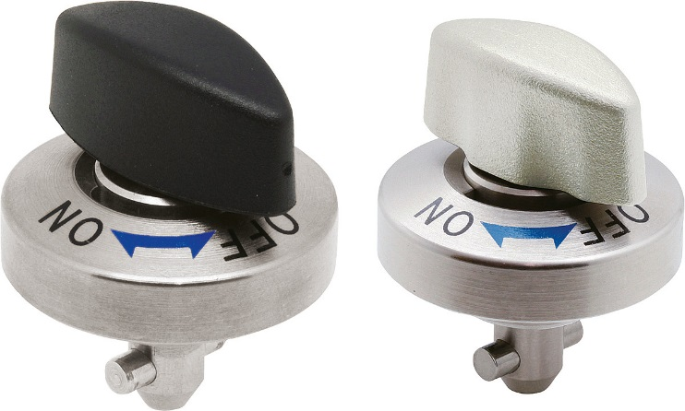  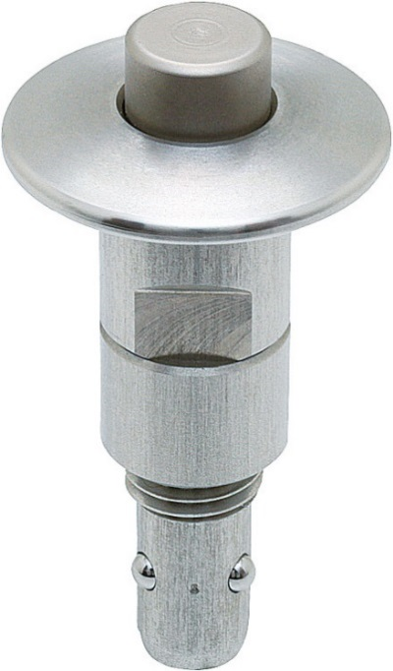 | Image file:  KIPP-Drehspannriegel-K1061.jpg  Image file:  KIPP-Kugelsperrbolzen-Edelstahl-K1063.jpg

Image copyright: Released for licence-free and royalty-free publication in speciality media.
Please cite the source and submit a reference.

