Press release Sulz am Neckar, Germany, September 2017

It’s all in the grip

KIPP presents a variable grip system for ball lock pins

HEINRICH KIPP WERK have expanded the range of ball lock pins just in time for the MOTEK 2017. Between the 9th and 12th October visitors in Stuttgart will be able to see, among other things the wide selection of grip types and experience the practical handling.

The stainless steel ball lock pins from KIPP are used for easy joining or fixating two components or workpieces. A secure lock is made by simply pressing and releasing a button. The special feature of these products is the high variability. In addition to the basic types, KIPP now offers three different plastic grip versions according to requirements. The mushroom grip is space saving, the L-grip enables intuitive handling and the T-grip has a convincing tangibility – all three versions have a similar design.
Another optical alternative is an additional version with a stainless steel mushroom grip.

The assembly of the ball lock pins is carried out on a modular basis, enabling KIPP to produce and offer large quantities at an attractive price. In addition to the standard black grey plastic mushroom, T and L grips, KIPP also offers powder-coated zinc T and L grips which can withstand much higher temperatures. All the actual pins of the ball lock pins are made of stainless steel and have a diameter of between 5 and 16 mm and a length of 10 to 80 mm, customer specific sizes are also available.

HEINRICH KIPP WERK will be presenting the ball lock pins together with other products in hall 3 at booth 3325. Our team is looking forward to welcoming interested visitors and inviting them to a warm drink in our own CAFÉ Lounge.

Characters including spaces:
Headline: 55 characters
Pre-head: 20 characters
Text: 1.598 characters
Total: 1.673 characters

HEINRICH KIPP WERK KG
Stefanie Beck, Marketing
Heubergstrasse 2
72172 Sulz am Neckar, Germany

Telephone: +49(0)7454 793-30
Email: stefanie.beck@kipp.com

Additional information and press photos
See www.kipp.com, Region: Germany, Category: News / Press area

Photo

KIPP Ball lock pins  Photo: KIPP  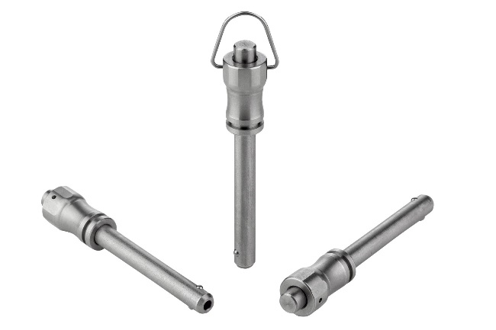  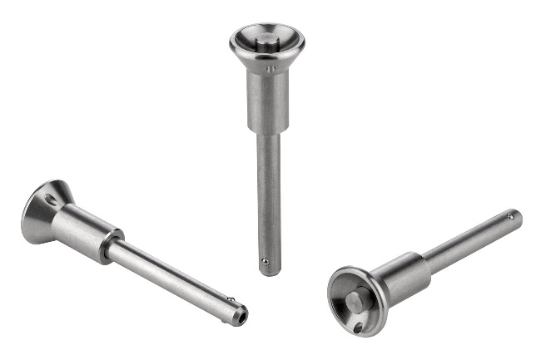  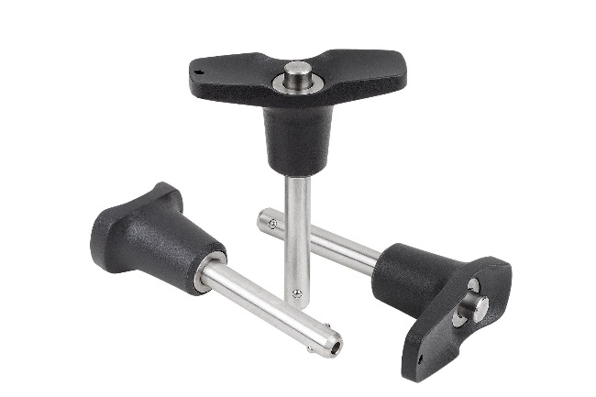 | Image file:  KIPP-Kugelsperrbolzen-Edelstahl-selbstsichernd-K0790.jpg  Image file:  KIPP-Kugelsperrbolzen-Pilzgriff-selbstsichernd-K0791.jpg  Image file:  KIPP-Kugelsperrbolzen-selbstsichernd-K0792.jpg

Image copyright: Released for licence-free and royalty-free publication in speciality media.
Please cite the source and submit a reference.

