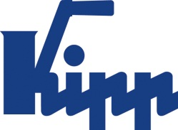

Press release Sulz am Neckar, Germany, August 2018

Self-righting for rapid setups

KIPP presents new self-aligning pads in four versions

HEINRICH KIPP WERK expands the the range of clamping devices with four versions of self-righting self-aligning pads. These simplify the machining of workpieces with sloping faces. When the clamp is released, self-aligning pad automatically returns to the start position. This has the effect of reducing setup times.

KIPP self-aligning pads are suitable for the flexible holding and support of workpieces and for realising a tension-free 3-point support. They adapt to a wide variety of contours, inclined surfaces or geometries. When under pressure, the self-aligning pad swivels to suit the form and returns to the start position when the pressure is released. This simplifies setups and shortens machining times compared to rigid self-aligning pads that require manual new realignments.

The new self-aligning pads have a high load capacity with a small size. An integrated O-ring prevents the penetration of dirt and foreign particles. Self-righting self-aligning pads are often used when machining cast items as these normally have differing geometries. They are also suitable as grip elements on robotic gripping arms. In addition, they can also be used as stops, rests and thrust pads in fixture construction and tool making.

KIPP offers the new self-aligning pads in four different versions and various materials: The Form C pads have a male thread, flattened ball and smooth support face. The Form F pads are the same as Form C but have a serrated support face. By both self-aligning pads the ball is made from hardened and blackened steel while the ball seat is made from phosphated Q&T steel.
The difference between Forms G and J and both other Forms is that G and J have press-fit pins instead of a male thread. Form G has a smooth support face and Form J is serrated. By these self-aligning pads the ball is made from phosphated Q&T steel and the ball seat from hardened and blackened steel.

Characters including spaces:
Headline: 53 characters
Pre-head: 30 characters
Text: 1.905 characters
Total: 1.988 characters

Additional information and press photos
See www.kipp.com, Region: Germany, Category: News / Press area

Photos

KIPP presents new self-aligning pads in four versions K1164 Photo: KIPP  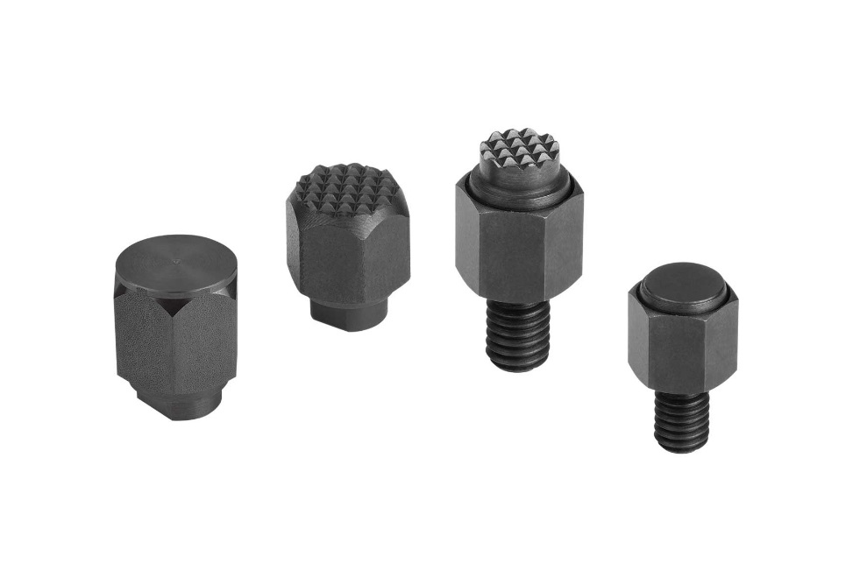 | Image file:  KIPP-Pendelauflagen-selbsttätig-rückschwenkend-K1164.jpg

Image copyright: Released for licence-free and royalty-free publication in speciality media.
Please cite the source and submit a reference.

