Press release Sulz am Neckar, Germany, March 2019

Quickly clamped, securely held - KIPP Toggle clamps

For decades, HEINRICH KIPP WERK has stood for durable products that simplify and expedite daily tasks. The new toggle clamps from KIPP adhere to this basic principle. The company offers a large number of new toggle clamps in three product categories.

Toggle clamps are used in e.g. clamping technology or in the tool making departments of automotive, metalworking, carpentry or plastic industries. They are used to hold and clamp workpieces for drilling, grinding, welding, bending and during inspection and assembly.

The KIPP steel or stainless steel toggle clamps have a long service life due to their high wear resistance and the oil-resistant bright red grips. In addition, they are easy to handle - due to the wide opening, they enable quick and unhindered placement and removal of workpieces. Low manual effort is sufficient to achieve high clamping forces.

HEINRICH KIPP WERK classifies the toggle clamps into three different types: Horizontal toggle clamps, Vertical toggle clamps and Push-Pull toggle clamps. The horizontal toggle clamps have a low overall height, while the push-pull clamps are characterised by a compact design and high holding forces. Additionally, the range includes latch- and hook clamps that are ideal for locking hatches and containers. Clamping spindles enable the clamping height of the toggle clamps to be easily manually adapted to the required application range.

Characters including spaces:
Headline: 51 characters
Text: 1.401 characters
Total: 1.452 characters

HEINRICH KIPP WERK KG
Stefanie Beck, Marketing
Heubergstrasse 2
72172 Sulz am Neckar, Germany

Telephone: +49(0)7454 793-30
Email: stefanie.beck@kipp.com

Additional information and press photos
See www.kipp.com, Region: Germany, Category: News / Press area

Photos

Quickly clamped, securely held - KIPP Toggle clamps  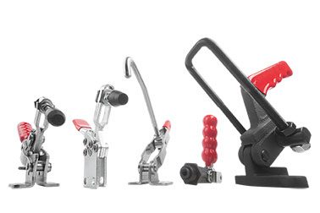 | Image file:  KIPP_toggle clamps_2019.jpg

Image copyright: Released for licence-free and royalty-free publication in speciality media.
Please cite the source and submit a reference.

