Press release Sulz am Neckar, Germany, May 2019

KIPP 5-axis clamping system for 40 tonne workpieces

HEINRICH KIPP WERK displays the 5-axis module clamping system size Ø 138 at the MOULDING EXPO. With heavy workpieces it has already proven itself in use with high stability and reliability.

A year ago, HEINRICH KIPP WERK presented the new 5-axis module clamping system for clamping workpieces that exceed 1 m in length. In the spring of 2019, just in time for the MOULDING EXPO the KIPP technicians can report the successful use of the system under extreme conditions - clamping a workpiece with a weight of 40 t.

The customer's requirement was to clamp a tool family for injection moulding machines - upright for the 5-side complete machining. The dimensions of the smallest part family was 2 m x 2 m x 0.8 m with a weight from 15 t. The largest family was 4 m x 4 m x 1.1 m and weighed up to 40 t.

The KIPP 5-axis modular clamping system in size Ø 138 is predestined for this application. After installation of the clamping system, the set-up time was optimised by over 300 %. Previously, the customer required 90 minutes for a setup, now it was a maximum of 20 minutes. A support weight of 10 t per module was realised. 4 basic modules of size Ø 138 were always used simultaneously. The workpiece was positioned by means of a centring aid on the base module for easier placement by crane.

The 138 modular system is compatible and universally applicable with the sizes already available (50 and 80). As XXL version it enables fastening with threads up to M 60. KIPP shows the product at the MOULDING EXPO in Stuttgart, Germany in May 2019 -
HALL 3 | BOOTH 3A13

Characters including spaces:
Headline: 51 characters
Text: 1.561 characters
Total: 1.612 characters

HEINRICH KIPP WERK KG
Stefanie Beck, Marketing
Heubergstrasse 2
72172 Sulz am Neckar, Germany

Telephone: +49 7454 793-30
Email: stefanie.beck@kipp.com

Additional information and press photos
See www.kipp.com, Region: Germany, Category: News / Press area

Photos

KIPP 5-axis clamping system for 40 tonne workpieces  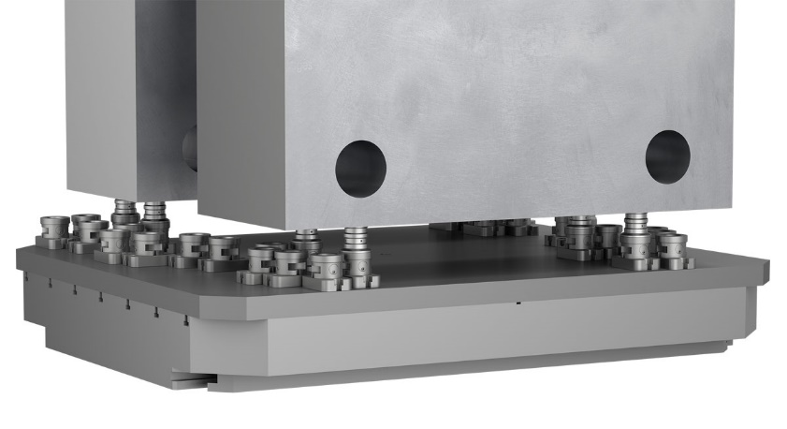 | Image file:  KIPP_5-Achs-Modul-Spannsystem_138_Anwendung.jpg

Image copyright: Released for licence-free and royalty-free publication in speciality media.
Please cite the source and submit a reference.

