Sulz am Neckar, July 2021

Practical and ergonomic:
Indexing plungers with cam lever from KIPP

HEINRICH KIPP WERK presents another new developement in the indexing plunger product group: Models in which the pin is disengaged using a cam lever are now entering the market. When the user moves the cam lever past the dead centre of the cam, the pin disengages. The advantages are the ergonomic design, flat construction, high temperature resistance and rapid adjustment.

Indexing plungers are amongst the standardised construction components that enable moving machine components to be adjusted quickly. In most cases, pulling on a knob or pull ring retracts a pin so that machine parts can be moved to another position and re-secured. With these new indexing plungers, this operation is carried out using a cam lever. A great advantage here is that the indexing plunger remains disengaged when the handle is moved over the cam dead centre. This solves problems such as, when several indexing plungers that cannot all be operated manually at the same time by one person are attached to a housing. The operator can comfortably disengage one pin after another without having to hold all grips in the open position. This function is otherwise only found on indexing plungers with an indexing slot, where the handle has to be rotated to the retracted position - this operation takes longer. In contrast, the products with cam lever are suitable for convenient, quick adjustment.

Another plus point is the ergonomic design of the cam lever, which permits easy handling with little effort. The levers are available in black and traffic red and are made of fibreglass-reinforced plastic. This plastic is resistant to high temperatures and permits permanent operating temperatures of ca.160 °C and short-term operating temperatures up to 250 °C. For the threaded sleeves and indexing pins, the user can choose between steel and stainless steel versions.
All threaded sleeves have fine threads and are available in 4 sizes (M10x1 / M12x1.5 / M16x1.5 / M20x1.5).

The cam levers can be rotated through 360° and are significantly flatter than mushroom or T-grips when idle. This also enables recessed mounting of the products, which avoids interfering contours.

(Characters including spaces: 2,215)

Image overview:

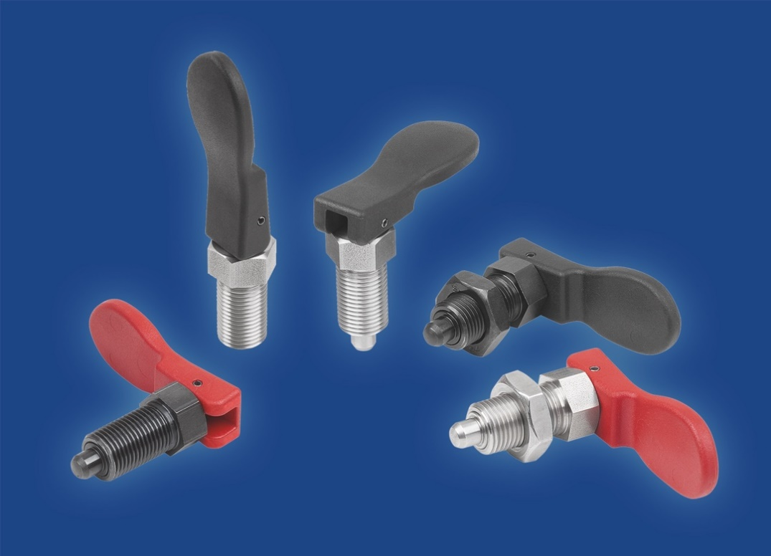

HEINRICH KIPP WERK GmbH & Co. KG
Stefanie Beck, Marketing
Heubergstrasse 2
72172 Sulz am Neckar

Telephone: +49 7454 793-30
Email: stefanie.beck@kipp.com

