Sulz am Neckar, February 2022
Quick clamping, secure fixating - with KIPP

Toggle clamps are used to hold and clamp workpieces. HEINRICH KIPP WERK offers these flexible aids in a Wide variety of designs, including innovative in-house developments under the names KIPPlock and KIPPlock+. New to the range are conductive ESD toggle clamps and smart status sensors that can be used to monitor the actuated status.

In production environments, electrical discharges can lead to the damage or destruction of parts, components or equipment. To prevent this, workstations in so-called ESD (Electrostatic Discharge) zones must be equipped down to the smallest component according to standards. This is no problem with the safe ESD toggle clamps that HEINRICH KIPP WERK has recently introduce to its range. In order to guarantee the conductivity the standards require, the grip elements and the protective pads are made of electrically conductive polyamide or elastomer. This permits the current to be relayed and dissipated via the steel frame.

The new Status sensors for toggle clamps enable the actuated status to be automatically read: the sensor detects whether the toggle clamp is open or closed so that the information can be electronically processed. This approach permits easy retrofitting of toggle clamps to create a smart production environment. The products were developed as part of the FEATUREgrip product series. With these intelligent components, users can use additional the information to make their digitised manufacturing processes more stable, precise and reliable.

KIPP toggle clamps are high quality, robust products and therefore well suited for applications in the machine construction sector. Steel and stainless steel versions are available. The wide range can be roughly divided into three different types: horizontal clamps, vertical clamps and push-pull clamps. These solutions are characterised by the one-handed operation, the clamping of the workpieces is carried out by the toggle lever principle. Versions with a horizontal or vertical foot permit the clamp to be easily installed in accordance with the respective mounting requirements.

The KIPPlock and KIPPlock+ series were developed by KIPP. These models are renowned for the ergonomic design of the grip and particularly user-friendly handling. High-quality materials, innovative joint bushings and corrosion-resistant surfaces ensure that all products effortlessly withstand 300,000 clamping cycles. KIPPlock+ also features an integrated safety lock. With the internal rod lock with automatic safety catch, nothing can get caught or snagged, and operation is even possible with thick working gloves.

(Characters including spaces: 2,647)

Image overview:
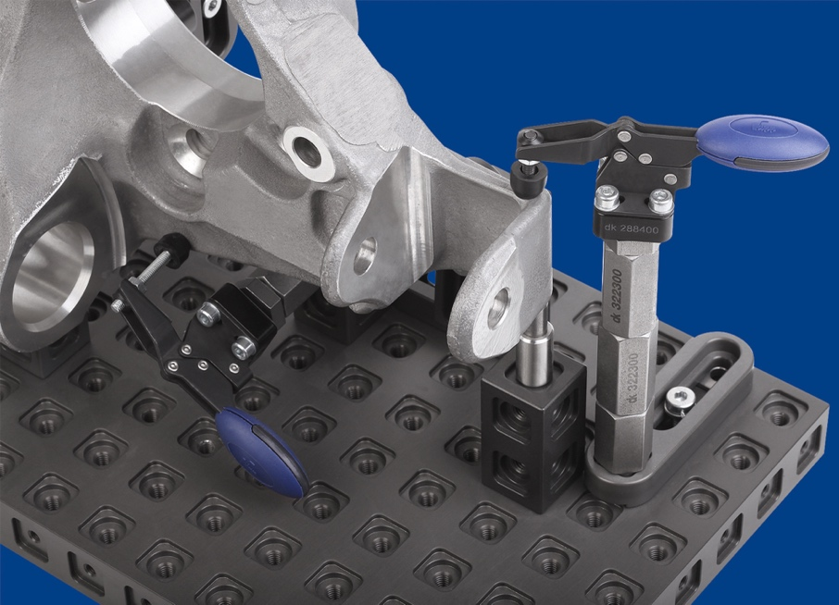
KIPP toggle clamps are high quality, robust products and therefore well suited for applications in the machine construction sector.
Image: KIPP

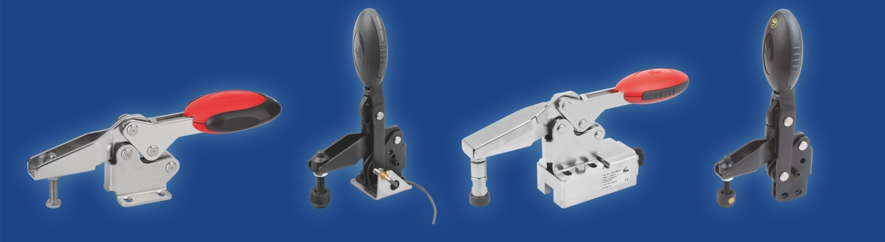
HEINRICH KIPP WERK offers toggle clamps in a variety of designs.
Image: KIPP

HEINRICH KIPP WERK GmbH & Co. KG
Stefanie Beck, Marketing
Heubergstrasse 2
72172 Sulz am Neckar, Germany

Telephone: +49 7454 793-30
Email: stefanie.beck@kipp.com

